**Insert School Logo**

**Semester One**

**Examination 2023**

**Question/Answer Booklet**

**Physical Education Studies**

**Units 1&2**

Name: _______________________________________________________

Teacher: ___________________________________________________

***TIME ALLOWED FOR THIS PAPER***

Reading time before commencing work: Ten minutes

Working time for the paper: Two and half hours

***MATERIALS REQUIRED/RECOMMENDED FOR THIS PAPER***

**To be provided by the supervisor:**

* This Question/Answer Booklet

**To be provided by the candidate:**

* Standard items: pens, pencils, eraser or correction fluid, ruler, highlighter.
* Special items: Calculators satisfying the conditions set by the SCSA for this subject.

***IMPORTANT NOTE TO CANDIDATES***

No other items may be taken into the examination room. It is **your** responsibility to ensure that you do not have any unauthorised notes or other items of a non-personal nature in the examination room. If you have any unauthorised material with you, hand it to the supervisor **before** reading any further.

**Structure of this paper**

|  |  |  |  |  |  |
| --- | --- | --- | --- | --- | --- |
| Section | Number of questions available | Number of questions to be answered | Suggested working time  (minutes) | Marks available | Percentage of exam |
| Topic One:  Multiple Choice | x | x | 30 | x | 20 |
| Section Two:  Short answer | x | x | 70 | x | 50 |
| Section Three:  Extended answer | x | x | 50 | x | 30 |
|  |  |  | **Total** | x | 100 |

**Instructions to candidates**

1. The rules for the conduct of Western Australian external examinations are detailed in the *Year 11 Information Handbook 2017.* Sitting this examination implies that you agree to abide by these rules.
2. Write your answers in this Question/Answer Booklet.

Answer all questions according to the following instructions.

Multiple-Choice: Answer **all** questions on the separate Multiple-choice Answer Sheet provided. For each question shade the box to indicate your answer. Use only a blue or black pen to shade the boxes. If you make a mistake, place a cross through that square, do not erase or use correction fluid, and shade your new answer. Marks will not be deducted for incorrect answers. No mark will be given if more than one answer is completed for any reason.

Short Answer and Extended Answer: Write answers to in this Question/Answer Booklet.

1. You must be careful to confine your responses to the specific questions asked and follow any instructions that are specific to a particular question.
2. Spare pages are included at the end of this booklet. They can be used for planning your responses and/or as additional space if required to continue an answer.
   * Planning: If you use the spare pages for planning, indicate this clearly.
   * Continuing an answer: If you need to use the space to continue an answer, indicate in the original answer space where the answer is continued, i.e. give the page number. Refer to the question(s) where you are continuing your work.

**Topic: Functional Anatomy (35 marks)**

This section has **10** questions. Answer **all** questions. Answer the five **(5)** Multiple-Choice questions on the separate Multiple-choice answer Sheet provided. Write your answers to the Short Answer and Extended Answer question in the spaces provided in this Question/Answer Booklet. Wherever possible, confine your answers to the line spaces provided. Use a blue or black pen (**not** pencil) for this section.

Spare pages are included at the end of this booklet. They can be used for planning your responses and/or as additional space if required to continue an answer.

Suggested working time: 50 minutes.

**Multiple Choice (5 marks)**

1. Which blood vessel would only carry deoxygenated blood?
2. Vena cava.
3. Aorta.
4. Pulmonary vein.
5. Capillaries.
6. Which muscle contracts to bring the knee closer to the chest during a tuck somersault?
7. Quadricep.
8. Hamstring.
9. Hip flexors.
10. Gastrocnemius.
11. The insertion point for the hamstring muscle is located on the:
12. Tibia.
13. Femur.
14. Patella.
15. Tarsals.
16. Turning the palm upwards to catch a falling cricket ball would be described as:
17. Pronation.
18. Flexion.
19. Extension.
20. Supination.
21. Diffusion of oxygen into the blood stream will occur in the:
22. Bronchioles.
23. Alveoli.
24. Lungs.
25. Diaphragm.

**Short Answer (20 marks)**

**Question 6 (5 marks)**

The heart pumps blood throughout the circulatory system to deliver oxygen to the working muscles.

(a) Identify what type of involuntary muscle the heart is. (1 mark)

___________________

(b) Identify the chamber of the heart into which freshly oxygenated blood enters. (1 mark)

___________________

(c) Identify the blood vessel that transports deoxygenated blood from the heart to the lungs.

(1 mark)

___________________

(d) Delivering oxygen and removing waste are two major functions of blood. Outline **two** other functions of blood.

(2 marks)

___________________

___________________

___________________

___________________

**Question 7 (5 marks)**

Joints enable movement in a variety of planes for optimal sporting performance. Complete the table below to demonstrate your understanding of different movement types.

|  |  |
| --- | --- |
| **Movement Type** | **Definition** |
| Flexion |  |
|  | Moving a limb away from the mid-line of the body |
| Circumduction |  |
|  | Moving the toes upwards towards the tibialis anterior |
| Pronation |  |

**Question 8 (4 marks)**

Muscles are attached to bones by soft tissues known as tendons at either end which pull upon the bone to create movement.

(a) Define the terms ‘origin’ and ‘insertion’, in relation to points of muscles. (2 marks)

___________________

___________________

___________________

___________________

(b) Identify the agonist and antagonist muscles of the Australian Football player when executing the drop punt.

(2 marks)

___________________

___________________

**Question 9 (6 marks)**

Gymnasts, in order to avoid injury, train by stretching their muscles beyond normal resting length. This increases the muscles extendibility.

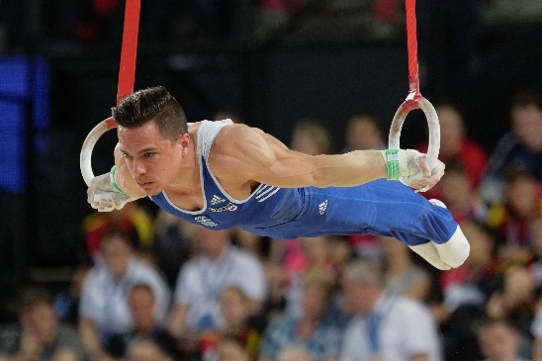

Identify and define the **three** other characteristics of skeletal muscle.

___________________

___________________

___________________

___________________

___________________

___________________

___________________

___________________

**Extended Answer (10 marks)**

**Question 10** (10 marks)

In 2021, Western Australian Peter Bol became a household name after narrowly missing out on a medal at the Tokyo Olympics, placing 4th in the 800m final. During qualifying he ran an Australian national record of 1min 44.11secs. Explain the mechanics of breathing that would have occurred during Peter Bol’s 800m race.

___________________

___________________

___________________

___________________

___________________

___________________

___________________

___________________

___________________

___________________

___________________

___________________

___________________

___________________

___________________

___________________

___________________

___________________

___________________

___________________

___________________

___________________

___________________

___________________

___________________

___________________

___________________

___________________

___________________

___________________

___________________

___________________

___________________

___________________

___________________

**End of Topic**

**Topic: Exercise Physiology (35 marks)**

This section has **9** questions. Answer **all** questions. Answer the five **(5)** Multiple-Choice questions on the separate Multiple-choice answer Sheet provided. Write your answers to the Short Answer and Extended Answer question in the spaces provided in this Question/Answer Booklet. Wherever possible, confine your answers to the line spaces provided. Use a blue or black pen (**not** pencil) for this section.

Spare pages are included at the end of this booklet. They can be used for planning your responses and/or as additional space if required to continue an answer.

Suggested working time: 50 minutes.

**Multiple Choice (5 marks)**

* + - 1. Which of the following would be an acute response to physical activity?

1. Decreased resting heart rate.
2. Increased capillarisation.
3. Increased maximal heart rate.
4. Perspiration.
   * + 1. High Glycaemic Index (GI) food sources are most appropriate for athletes to:
          1. provide muscles with a rapid source of energy immediately prior and during competition.
          2. increase glycogen stores in the muscle and liver.
          3. improve efficiency of the aerobic energy system during short intervals.
          4. provide muscles with a sustained release of energy during competition.
       2. When compiling a training program, which component of fitness would be of most importance to a 100m sprinter?
          1. Cardiorespiratory endurance.
          2. Agility.
          3. Speed.
          4. Muscular strength.
       3. Which method of training would be most appropriate for a basketball point guard?
5. Short interval training.
6. Continuous training.
7. Plyometrics.
8. Resistance training.
   * + 1. The predominant energy system utilised during the Long Jump in athletics would be:
9. Lactic Acid.
10. ATP-CP.
11. Aerobic.
12. Inter-play of all three energy systems.

**Short Answer (20 marks)**

**Question 6 (8 marks)**

CrossFit has recently become a popular recreational training activity for personal fitness. The CrossFit Games incorporates a variety of demanding exercises which require different training methods and muscular contractions.

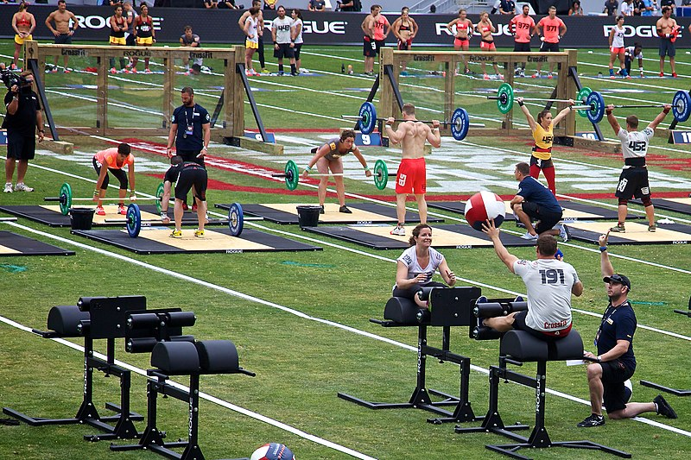

1. Identify thetraining type that would benefit explosive movements which are often required at the CrossFit Games. (1 Mark)

___________________

1. Explosive movements can often cause injuries to soft tissues such as ligaments, tendons and muscles. Define which training method should be incorporated to lower the risk of injury and provide an example for a CrossFit athlete. (3 Marks)

___________________

___________________

___________________

___________________

1. CrossFit requires muscular contractions that differ between the exercise being executed. Outline the **two** types of muscular contractions necessary for the following movements.

(4 Marks)

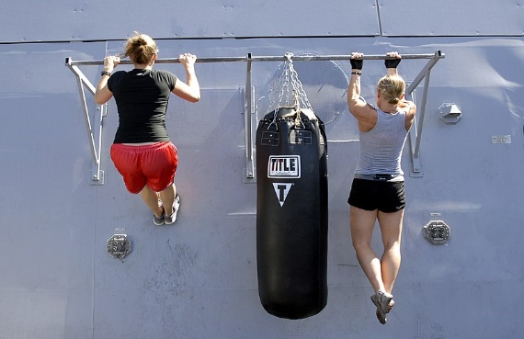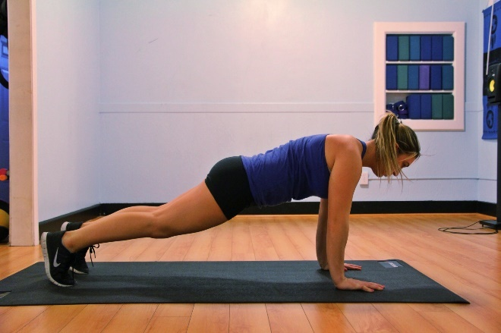

**Plank Pull Ups**

___________________

___________________

___________________

___________________

___________________

___________________

**Question 7 (7 marks)**

The marathon is an endurance event run over a distance of 42.2km. Elite athletes will take between 2 - 2½ hours to complete the distance.

(a) Identify the predominant energy system when competing in a marathon. (1 mark)

___________________

(b) In order to compete for 2 - 2½ hours at optimal performance, athletes must consider their nutritional requirements prior to competition. Describe how a marathon runner would utilise their different energy sources to fuel themselves throughout the race.

(6 marks)

___________________

___________________

___________________

___________________

___________________

___________________

___________________

___________________

**Question 8 (5 marks)**

During the Australian Rules Football pre-season, players incrementally improve their aerobic conditioning to prepare for the rigour and stress which will be placed on their physiological systems during the season.

1. Identify the principle of training players will apply to increase their fitness during pre-season. (1 Mark)

___________________

1. Identify and define **two** variables Australian Rules Football players can increase to place added stress upon the physiological systems to cause adaptations. (4 Marks)

___________________

___________________

___________________

___________________

___________________

___________________

**Extended Answer (10 marks)**

**Question 9 (10 marks)**

In 2022, Jai Hindley made history as the first Australian cyclist to win the three-week Giro d’Italia Grand Tour. Each stage ranged from 120km to over 200km, taking up to 6 hours in length to complete. Jai’s endurance has been extensively trained to endure the stress of competition since the weekly Perth river loops and hills training rides that he used to complete as a junior.

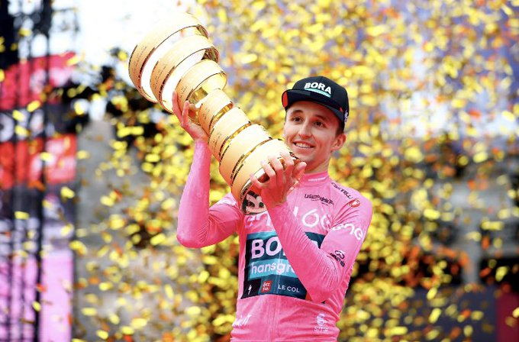

Using your knowledge of the long term cardiovascular and respiratory effects of training, discuss **five** chronic adaptations Jai would have developed as a result of his training to be able to compete at his optimal performance state.

___________________

___________________

___________________

___________________

___________________

___________________

___________________

___________________

___________________

___________________

___________________

___________________

___________________

___________________

___________________

___________________

___________________

___________________

___________________

___________________

___________________

___________________

___________________

___________________

___________________

___________________

___________________

___________________

___________________

___________________

**End of Topic**

**Topic: Biomechanics (35 marks)**

This section has **9** questions. Answer **all** questions. Answer the five **(5)** Multiple-Choice questions on the separate Multiple-choice answer Sheet provided. Write your answers to the Short Answer and Extended Answer question in the spaces provided in this Question/Answer Booklet. Wherever possible, confine your answers to the line spaces provided. Use a blue or black pen (**not** pencil) for this section.

Spare pages are included at the end of this booklet. They can be used for planning your responses and/or as additional space if required to continue an answer.

Suggested working time: 50 minutes.

**Multiple Choice (5 marks)**

1. In golf, the pin (hole) can be higher than the tee off shot. Which angle of projection would seem the most accurate for a tee off shot in this circumstance?
2. 20 degrees.
3. 45 degrees.
4. 65 degrees.
5. 90 degrees.
6. A 50m freestyle swimmer would be best describe as having which type of motion?
7. Linear motion.
8. General motion.
9. Angular motion.
10. Projectile motion.
11. Ricky Ponting, former Australian Test Captain, was famed for his attacking cricket pull shot. A cricket pull shot is best performed using a:
12. simultaneous movement to produce maximum accuracy.
13. simultaneous movement to produce maximum force.
14. sequential movement to produce maximum accuracy.
15. sequential movement to produce maximum force.
16. Which of the following would best define acceleration?
17. The speed of an object in a given direction.
18. The rate at which an objects velocity changes in relation to time.
19. The rate at which an object changes speed.
20. The motion of a moving object, measured as a product of its mass and velocity.

5. In American gridiron, the offensive linesman position themselves to protect their quarterback by stabilising themselves to withstand the defenders tackle.

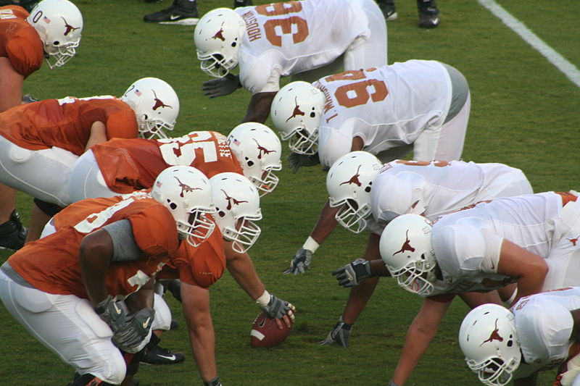

Which of the following would you recommend to players to improve their balance and stability?

* 1. Lower their centre of mass, line of gravity over base of support, increase points of contact.
  2. Raise their centre of mass, line of gravity over base of support, increase points of contact.
  3. Lower their centre of mass, line of gravity outside base of support, increase points of contact.
  4. Lower their centre of mass, line of gravity over base of support, decrease points of contact.

**Short Answer (20 marks)**

**Question 6 (4 marks)**

The bicep curl is a common exercise utilised by weightlifters to gain strength.

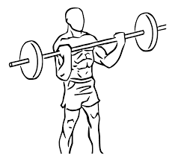

* + - * 1. Using your understanding of levers, label the components of the lever shown in the bicep curl below:

(3 marks)

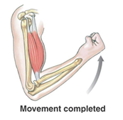

* + - * 1. Identify the class of lever you have labelled. (1 mark)

___________________

**Question 7 (4 marks)**

Define the **two** types of balance that a gymnast may display in a beam routine and provide a relevant example for each.

___________________

___________________

___________________

___________________

___________________

___________________

**Question 8 (12 marks)**

Sally Pearson competed in the 100 metres hurdles for Australia at the Olympics. The race consists of ten hurdles at a height of 83.8cm placed along a straight course of 100 metres.

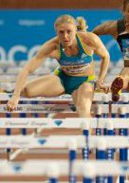

* 1. Using your biomechanical knowledge, identify and define the types of motion that Sally Pearson would demonstrate when hurdling. Include a relevant example for her movement.

(8 marks)

___________________

___________________

___________________

___________________

___________________

___________________

___________________

___________________

___________________

___________________

___________________

___________________

___________________

___________________

___________________

* 1. The finish line is 100m from the starting blocks. Define displacement. (1 mark)

___________________

Sally Pearson uses pressure sensor angled starting blocks at the start of her 100m hurdles race.

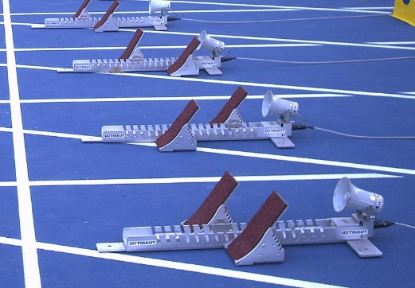

* 1. State Newton’s 3rd Law of Motion and describe how Sally utilises the starting blocks to optimise her start. (3 marks)

___________________

___________________

___________________

___________________

___________________

**Extended Answer (10 marks)**

**Question 9** (10 marks)

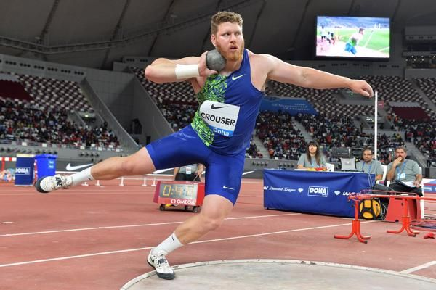Shot Put involves power, agility and strength to forcefully propel the 7.26kg (male) shot put the greatest distance. The shot is ‘put’ from a 2.13m wide circle with a 10cm high toe-board at the front to assist athletes.

American Ryan Crouser holds the current men’s world record with an incredible 23.37m. Elite shot putters will regularly throw over 20m. Using your biomechanical knowledge of projectile motion, explain how shot putters can achieve maximal distance.

(10 marks)

___________________

___________________

___________________

___________________

___________________

___________________

___________________

___________________

___________________

___________________

___________________

___________________

___________________

___________________

___________________

___________________

___________________

___________________

___________________

___________________

___________________

___________________

___________________

___________________

___________________

___________________

___________________

___________________

___________________

___________________

**End of Topic**

**Topic: Sports Psychology (35 marks)**

This section has **10** questions. Answer **all** questions. Answer the five **(5)** Multiple-Choice questions on the separate Multiple-choice answer Sheet provided. Write your answers to the Short Answer and Extended Answer question in the spaces provided in this Question/Answer Booklet. Wherever possible, confine your answers to the line spaces provided. Use a blue or black pen (**not** pencil) for this section.

Spare pages are included at the end of this booklet. They can be used for planning your responses and/or as additional space if required to continue an answer.

Suggested working time: 50 minutes.

**Multiple Choice (5 marks)**

* + - 1. Which of the following statements about arousal is correct?

1. Boxing requires a high level of arousal for optimal performance.
2. Novice performers require a high level of arousal for optimal performance.
3. Archery requires a high level of arousal for optimal performance.
4. Cliff top diving requires a high level of arousal for optimal performance.
   * + 1. A netball player must process the movements and positions of team mates to make a successful pass. The players attentional focus is:
5. Narrow and internal.
6. Narrow and external.
7. Broad and internal.
8. Broad and external.
   * + 1. Marie sets herself a goal to be able to bench press 65kg by the end of her AFLW pre-season. What type of goal is this?
9. Personal goal.
10. Process goal.
11. Outcome goal.
12. Physical goal.
    * + 1. Michael Jordan was one of the greatest basketball players of all time. He was known for his intense focus, internal drive and game winning shots. He was often described as being ‘in the zone’. Which statement best defines being ‘in the zone’?
13. Optimal performance trait.
14. Optimal performance mood.
15. Optimal performance state.
16. Optimal performance self-confidence.
    * + 1. Using selective attention to focus upon relevant stimuli during a tennis rally would benefit performance by:
    1. improving concentration.
    2. controlling arousal.
    3. increasing self-confidence.
    4. reducing stress.

**Short Answer (20 marks)**

**Question 6 (9 marks)**

Setting a specific and measurable goal is important for school students working towards an inter-school athletics competition so they have a time, distance or height to work towards.

* 1. List **five** other characteristics of effective goal setting. (5 marks)

___________________

___________________

___________________

___________________

___________________

___________________

* 1. Provide an example of a specific athletics event goal and how a school student would measure their progress towards this as they approach their inter-school athletics competition.

(4 marks)

___________________

___________________

___________________

___________________

___________________

___________________

**Question 7 (4 marks)**

Motivation is an important factor in the pathway to achieve long term goals. Explain the **two** types of motivation and provide a sporting example for each.

(4 marks)

___________________

___________________

___________________

___________________

___________________

___________________

**Question 8 (3 marks)**

Sophie is a 43-year-old who enjoys socially jogging around her local 5km Park Run course with friends each Saturday morning. List **three** factors that influence a person’s choice of involvement and reasons for taking part in sporting activities. (3 marks)

___________________

___________________

___________________

**Question 9 (4 marks)**

Nideffer’s Model explains the attentional demands athletes require in varying sporting situations. The direction scale relates to whether a player’s focus should be internal or external. Describe the width scale and apply this to a sporting context of your choice.

(4 marks)

___________________

___________________

___________________

___________________

___________________

**Extended Answer (10 marks)**

**Question 10** (10 marks)

Tiger Woods won the US Master Golf Tournament in 2019 after a remarkable comeback from injury. More notably, he won the tournament on the fourth day of play when Francesco Molinari, who was comfortably leading the the tournament, psychologically capitulated in the final nine holes as he was being overcome with pressure!

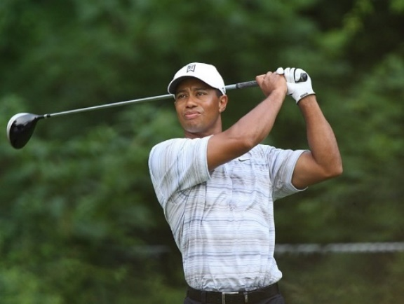

* 1. Draw a fully labelled diagram of the Inverted U hypothesis, placing the points Tiger Woods and Francesco Molinari would be at psychologically, over the last nine holes.

(5 marks)

Tiger Woods body language, facial expressions and demeanour were quite contrasting to Francesco Molinari’s as the pressure intensified and Francesco’s lead diminished.

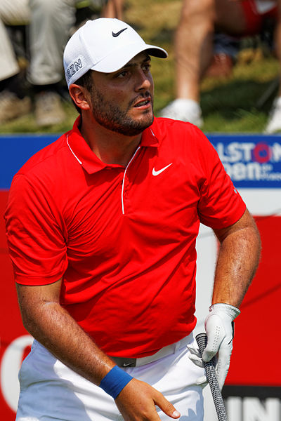

* 1. Compare and contrast **four** differing physiological and psychological symptoms both players would have been experiencing during the final nine holes.

(4 marks)

|  |  |  |
| --- | --- | --- |
| **Player** | **Physiological** | **Psychological** |
| **Tiger Woods** |  |  |
| **Francesco Molinari** |  |  |

* 1. Francesco Molinari hit numerous shots into water hazards in the final holes of the tournament. The ‘fear of failure’ can become a self-fulfilling prophecy for many athletes that ‘choke’ under pressure. Define the self-fulfilling prophecy.

(1 mark)

___________________

**End of Topic**

**Topic: Motor Learning & Coaching (35 marks)**

This section has **10** questions. Answer **all** questions. Answer the five **(5)** Multiple-Choice questions on the separate Multiple-choice answer Sheet provided. Write your answers to the Short Answer and Extended Answer question in the spaces provided in this Question/Answer Booklet. Wherever possible, confine your answers to the line spaces provided. Use a blue or black pen (**not** pencil) for this section.

Spare pages are included at the end of this booklet. They can be used for planning your responses and/or as additional space if required to continue an answer.

Suggested working time: 50 minutes.

**Multiple Choice (5 marks)**

* + 1. Archery would be best classified as a:

1. fine skill.
2. gross skill.
3. continuous skill.
4. serial skill.
   * 1. Which of the following is an example of an athlete utilising proprioceptive cues to improve performance?
5. A diver adjusting their body position in mid-air to enter the water cleanly.
6. A basketball point guard changing their choice of pass due to player movement.
7. A soccer player passing the ball after a hearing a teammate call ‘man-on’.
8. A golfer changing their choice of club after looking at the distance of the pin (hole).
   * 1. Usain Bolt looking up to see his 100m world record time on the screen would be classified as which type of feedback?
9. Knowledge of performance.
10. Knowledge of result.
11. Concurrent.
12. Positive.
    * 1. A cricket batsman observing the position of the ball in the bowler’s hand and type of release would be at which phase of the Information Processing Model?
         + 1. Identification of stimulus / input phase.
           2. Response identification/decision-making phase.
           3. Response/output phase.
           4. Feedback phase.
      2. The purpose of feedback is to:
13. provide constructive criticism.
14. reinforcement of gross motor errors.
15. increase motivation.
16. reinforcement of fine motor control.

**Short Answer (20 marks)**

**Question 6 (2 marks)**

Elite athletes can use proprioceptive cues or stimuli to detect when they need to modify their skill execution. Identify **two** alternative cues that may be necessary for a young Rugby player just starting to learn the game.

(2 marks)

___________________

___________________

___________________

**Question 7 (5 marks)**

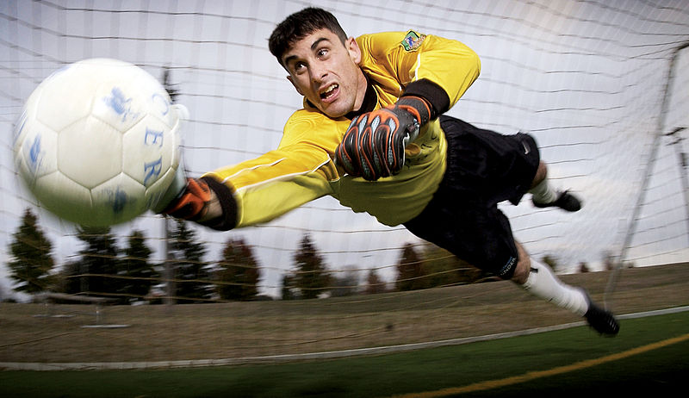Soccer goal keepers must ‘read the play’ and react quickly with the correct decisions to save the ball.

Complete the following flow chart that outlines each stage of the Information Processing Model.

Identification of stimulus by sensory system (sight, sound, touch) from environment.

**Response Identification / Decision Making / Processing**

**Feedback**

**Question 8 (5 marks)**

* 1. Outline the difference between the following: (2 marks)

Knowledge of Results:

___________________

___________________

Knowledge of Performance:

___________________

___________________

* 1. Identify the **three** purposes of effective feedback. (3 marks)

___________________

___________________

___________________

**Question 9 (8 marks)**

Skills can be classified and defined by the characteristics they possess. Complete the table below:

|  |  |  |
| --- | --- | --- |
| **Skill Classification** | **Definition** | **Sporting Example** |
| Discrete |  | Swimming dive |
| Gross |  |  |
|  | The skill is performed in a variable / changing environment. | Netball passing in a passage of play |
| Fine |  | Pistol shooting |
|  | The skill has a sub-routines that are linked together to form a more complicated skill or entire motor programme. | Triple Jump. |
|  |  | Rowing. |

**Extended Answer (10 marks)**

**Question 10** (10 marks)

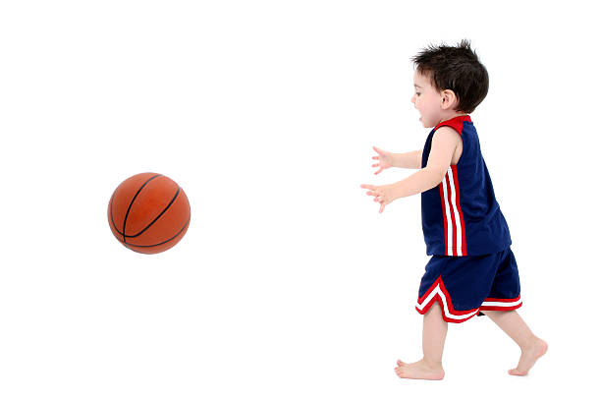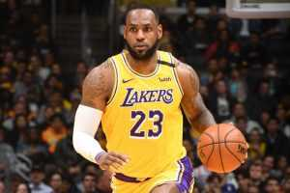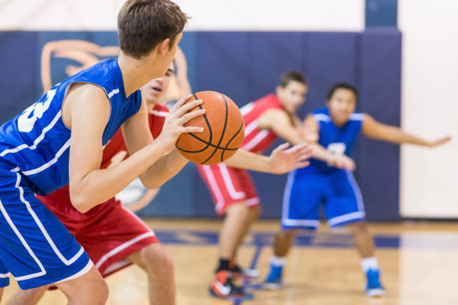

**Image A Image B Image C**

The three basketball players above are at different phases of their basketball experience. The Fitts and Posner Motor Learning Model provides the characteristics of performance within each phase. Identify which image you would expect the basketball player to spend the most time in and explain the characteristics and appropriate type of feedback that should be provided for each phase of learning.

(10 marks)

___________________

___________________

___________________

___________________

___________________

___________________

___________________

___________________

___________________

___________________

___________________

___________________

___________________

___________________

___________________

___________________

___________________

___________________

___________________

___________________

___________________

___________________

___________________

___________________

___________________

___________________

___________________

___________________

___________________

___________________

___________________

___________________

___________________

___________________

___________________

___________________

___________________

___________________

___________________

___________________

___________________

___________________

___________________

**End of Topic**

**Additional working space**

Question number(s): ……………………

**Additional working space**

Question number(s): ……………………

**ACKNOWLEDGEMENTS**

**Functional Anatomy**

Question 8

Image of the Australian Footballer Drop Punt

[**https://en.wikipedia.org/wiki/Punt_(Australian_football)#/media/File:Australian_rules_drop_punt.jpg**](https://en.wikipedia.org/wiki/Punt_(Australian_football)#/media/File:Australian_rules_drop_punt.jpg)

Question 9

Image of Gymnast

[**https://commons.wikimedia.org/wiki/File:2015_European_Artistic_Gymnastics_Championships_-_Rings_-_Eleftherios_Petrounias_03.jpg**](https://commons.wikimedia.org/wiki/File:2015_European_Artistic_Gymnastics_Championships_-_Rings_-_Eleftherios_Petrounias_03.jpg)

**Exercise Physiology**

Question 6

Image of CrossFit Games

[**https://commons.wikimedia.org/wiki/File:2013_CrossFit_Games_-_Stadium_relay.jpg**](https://commons.wikimedia.org/wiki/File:2013_CrossFit_Games_-_Stadium_relay.jpg)

Question 6 (c)

Image of Plank

[**https://commons.wikimedia.org/wiki/File:Plank.jpg**](https://commons.wikimedia.org/wiki/File:Plank.jpg)

Question 6 (c)

Image of Pull Up

[**https://commons.wikimedia.org/wiki/File:Flickr_-_Official_U.S._Navy_Imagery_-_Sailors_work_out_aboard_USS_Green_Bay..jpg**](https://commons.wikimedia.org/wiki/File:Flickr_-_Official_U.S._Navy_Imagery_-_Sailors_work_out_aboard_USS_Green_Bay..jpg)

Question 9

Image of Jai Hindley

[**https://en.wikipedia.org/wiki/Jai_Hindley#/media/File:JaiHindleyGiro2022.jpg**](https://en.wikipedia.org/wiki/Jai_Hindley#/media/File:JaiHindleyGiro2022.jpg)

**Biomechanics**

Question 5

Image of Gridiron Line of Scrimmage

[**https://en.wikipedia.org/wiki/Line_of_scrimmage#/media/File:2006_UT_football_fall_scrimmage.JPG**](https://en.wikipedia.org/wiki/Line_of_scrimmage#/media/File:2006_UT_football_fall_scrimmage.JPG)

Question 6

Image of Bicep Curl

[**https://commons.wikimedia.org/wiki/File:Wide_grip_standing_biceps_curl_with_barbell_2.svg**](https://commons.wikimedia.org/wiki/File:Wide_grip_standing_biceps_curl_with_barbell_2.svg)

Question 6 (a)

Image of Bicep Curl Movement Analysis

**chrome-extension://efaidnbmnnnibpcajpcglclefindmkaj/https://cotswold.gloucs.sch.uk/wp-content/uploads/2018/07/Y11-Summer-Work-PE-2-2018.pdf**

Question 8

Image of Sally Pearson

[**https://commons.wikimedia.org/wiki/File:Sally_Pearson-cropped.jpg**](https://commons.wikimedia.org/wiki/File:Sally_Pearson-cropped.jpg)

Question 8 (c)

Image of Starting Blocks

[**https://en.wikipedia.org/wiki/Starting_blocks#/media/File:PressureSensitiveStartingBlocks.jpg**](https://en.wikipedia.org/wiki/Starting_blocks#/media/File:PressureSensitiveStartingBlocks.jpg)

Question 9

Image of Ryan Crouser

[**https://worldathletics.org/news/feature/ryan-crouser-shot-put**](https://worldathletics.org/news/feature/ryan-crouser-shot-put)

**Sports Psychology**

Question 10 (a)

Image of Tiger Woods

[**https://commons.wikimedia.org/wiki/File:Tiger_Woods_drives_by_Allison.jpg**](https://commons.wikimedia.org/wiki/File:Tiger_Woods_drives_by_Allison.jpg)

Question 10 (b)

Image of Francesco Molinari

[**https://commons.wikimedia.org/wiki/File:Open_de_France_2015_16.jpg**](https://commons.wikimedia.org/wiki/File:Open_de_France_2015_16.jpg)

**Motor Learning & Coaching**

Question 7

Image of Soccer Goalkeeper

[**https://commons.wikimedia.org/wiki/File:Soccer_goalkeeper.jpg**](https://commons.wikimedia.org/wiki/File:Soccer_goalkeeper.jpg)

Question 10

Image A of Basketball Toddler

[**https://www.istockphoto.com/photo/adorable-toddler-boy-playing-basketball-barefoot-over-white-gm96644499-640031**](https://www.istockphoto.com/photo/adorable-toddler-boy-playing-basketball-barefoot-over-white-gm96644499-640031)

Question 10

Image B of Basketball Teenager

[**https://www.istockphoto.com/photo/boys-high-school-basketball-team-gm671176544-122831381?phrase=teenager%20basketball**](https://www.istockphoto.com/photo/boys-high-school-basketball-team-gm671176544-122831381?phrase=teenager%20basketball)

Question 10

Image C of Lebron James

[**https://ourdailynewsonline.com/2020/08/06/lebron-brushes-off-trump-blast-we-could-care-less/lebron_james_lal/**](https://ourdailynewsonline.com/2020/08/06/lebron-brushes-off-trump-blast-we-could-care-less/lebron_james_lal/)

WATP acknowledges the permission of the School Curriculum and Standards Authority in providing instructions to students.